# 6 Diary Management

Diaries primarily focused on collecting the data from the customer related to their shopping and shopping receipts

This is mainly used to check whether the individual is giving the data for each and every period in the correct time based on which points are allocated

**Types of Diary**

Paper Diary

Online Diary

Every week Panel manager will be scanning the diary information for previous period. While scanning the diary, panel manager has to specify the Panel, diary receive date, Incentive Type, Incentive reason, points, Business id and period

**There are 3 Sub menu’s in Daries**

1.Diary Scanning

2.Diary Management

3.Manual Import

However, GPM does not have all the purchase information. It primarily contains demographic information and very limited purchase information of the panellists."

These three pages fall under Diaries, and the main goal is to collect data from panellists.

Based on this data, we can gain insights into why people in different countries make certain purchases during specific periods.

This information helps businesses make informed decisions before launching new products.

**Diary Scanning**

Import data from the spreadsheet or Manual entry via application screen

How the data is collected

Under that panel, if a panellist did any shopping during a specific period, he provides that data which is saved using the diary functionalities in the GPM application

This is an old functionality we built earlier where,

1. Customers **receive a set of templates to fill in their shopping designs** or collect their receipts. They then **submit these receipts to GPM**

From the GPM side, a panellist scans and uploads the collected receipts. This way, the data is filled in against the respective panellist or business ID.

Nowadays, we have redeveloped this functionality and have different applications, such as the **Web application and Mobile application.**

User will scan the receipts, and the data would be directly inserted against the respective business ID and synchronized with the GPM application. This is the latest functionality in the Shopics application

However, we will continue with the diaries as some countries might still be using them. We are not certain, so we will proceed accordingly.

Basically, we want customers' data, specifically their shopping details. We want that data from their receipts, either by scanning the barcodes on the receipts or the barcodes on their products.

1. One method involves a **scanner device that we distribute to the panellists** or business IDs associated with us. They use this scanner to scan the receipts.

To collect this data, we use scanner devices that resemble a small mouse. By clicking a button, the panellists scan the barcodes, and the data is entered into the backend.

1. Another method involves **sending paper diaries**, which are essentially notebooks. Customers or business IDs fill in the data about their purchases in these diaries within a specified time period. categorize the data by year, period, and week to track when the shopping occurred.

The data manipulation and collection teams then analyse this data to generate reports. These reports provide insights into current shopping trends, such as what people are buying, when they are buying, and what motivates their purchases.

All this data is then integrated into the GPM application on our side.

There are different ways of collecting data, **depending on the region**. For example, in some **Asian countries**, paper IDs are used, while in others, online diaries are utilized where panellists submit their information online, which then gets transferred to the GPM using FTP. Additionally, there is a self-fill link, and GPM is live in India.

1. **In India**, data collection methods include **interviewer-based collection and self-filling**, depending on the panel. For instance, if it is a baby panel, the data collection is interviewer-based, meaning field workers who are contract workers for Kantar collect the data.

A person is sent in person to the panellist's home to collect information in India. The collection period is from the 21st to the end of the month. Before the visit, they call the panellist to ask about their purchases for the month.

For example, if a panellist bought biscuits and chocolates, they are asked to keep the wrappers for cross-verification.

The process varies by market. In Spain, it might be different, but in India, panellists are asked to keep the wrappers. When the interviewer visits, they verify the purchases by checking the wrappers. This information is then entered into the GPM, detailing the number of wrappers and items bought for that month.

The interviewer asks the panellist to show the wrappers. The panellists show the wrappers, and this information is entered into the GPM, detailing how many wrappers and items were bought for a particular month.

## Queue Mob

Another way of collecting data is through self-filling. Once a panellist is recruited, their information is initially fed into a third-party tool called Queue Mob.

From queue Mob, the information is pulled into the GPM. This process varies by country. In some countries, panellists are created in TVN, another third-party tool used in France, Asia, and Spain. From there, the panellist information is transferred to the GPM.

Panellists are not only created in GPM, and the information is not only collected by one or two methods. Each market has its own process.

## Hand diaries

Hand diaries are still an important part of the application. A physical template with a barcode is provided to panellists, who fill in the data and then courier it to the Kantar office.

This process is currently used in countries like Taiwan, Vietnam, and a few other Asian countries. These paper diaries are then scanned using a barcode reader, which detects the panellist ID and populates it in the business ID field.

## Online diaries

SSIS

Online diaries are another method, which is an automatic process managed by SSIS. Files are received daily through a scheduled job, depending on the country. The use of online diaries or paper diaries varies by panel.

For example, baby panels might use paper IDs, while lady and male panels might use online diaries. Some panels use both methods, depending on the country and how they prefer to collect information

Data is imported from the SSIS package, which collects data from a third-party tool. The third party provides a file via FTP, which is accessed and downloaded into the SSIS path.

Once the file is downloaded, the SSIS package is triggered, and the data is populated into the database. In the GPM application, data is imported from SSIS automatically.

Typically, SSIS runs automatically, or a user places the file in a specific SSIS folder. This process is managed by a job, which requires creating the job and the logic for SSIS."

GPM collects only the metadata. It does not have the full panellist purchase information. We only know whether the panellists have purchased data for the week, either through paper IDs or online.

There are a few other questions we ask the panellists to collect additional information, which can be shared with other teams.

## Application pages – Diary Scanning

Now, let's move on to the application pages.

For the main menu Diaries, click the Diary Scanning

Click and Select the panel and select anyone of the panel.

**Incentive: -**

Firstly, the incentive needs to be created

For example, if a panellist provides data, we might award them 120 or 170 points, depending on the data provided.

The incentive type and reason are based on the panel. We have a screen where you can create an incentive type.

Incentives menu -> Incentive types

The incentive type is not panel-specific, but the incentive reason is panel-specific.

First, you need to create a type for an incentive. For example, an incentive type could be 'submission points.' The incentive reason might vary, such as the first day, second day, or third day of submission. If you submit on the first day, you might receive more points compared to submitting on the second or third day.

For redemption, which means exchanging points for gifts, you also need to have a type. For example, a redemption type could be 'kitchen items,' and within that type, you might have specific items like a mixer or grinder.

This way, we can manage different incentive types and reasons, as well as redemption types, to reward panellists appropriately.

Whichever option is needed can be selected. The incentive reason is always associated with a panel. The number of points to be credited can be specified.

On the incentive screen, each incentive type and reason have a unique code. The reason is a label that can be changed, so the code is relied upon during imports. For each incentive reason, a unique code is generated.

There is an option to override points. If the 'can override' checkbox is unchecked, only the specified points (e.g., 100 or 200 points) will be credited. If 'can override' is checked, points within a specified range (e.g., 50 to 100 points) can be credited. For example, 75 points can be credited if within the range.

A validity period can be set for points. Points will be credited within the valid period. If the validity period is exceeded, the points will not be credited, and an error message will be displayed during imports.

The panel for which the incentive is intended can be selected. If the incentive is for all panels, the '‘whole’' button can be checked. Otherwise, specific panels can be selected.

This is how incentives are created. This reference data is displayed on the diary management screen based on the panel. Incentive types are not panel-based, so all incentive types are displayed. However, the incentive reason is always linked to a panel and calendar.

Click and Select the Received Date.

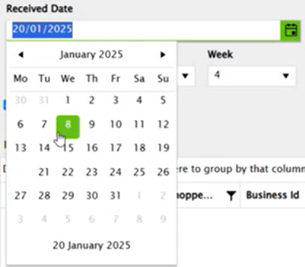

Receive date will be default today’s system date, Period (YYYY.PP. WW) will be one-week previous period as default and Process sorted diaries default will be checked

Here, entries can be added based on the year, period, week, and business ID.

The panels configured in the application will be displayed, and for each panel, the linked business IDs can be searched.

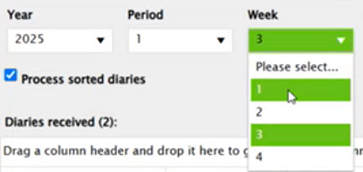

Entries can then be added by selecting the year, period, week, and other relevant details for the diary scan.

**Calendar:-**

There are 2 types of calendars

1) Country calendars – default calendar

2) Panel calendars - User can create his own calendar to a panel, in that case user calendar is overridden by the country calendar, only one calendar can be assigned to a panel

If a panel has a calendar, it gets populated; otherwise, the country calendar is used. Calendars are very important in GPM as diary scanning and other processes depend on them."

Click the name box and write a name in the text box.

And click and select the panel, Start year, Number of years, Start date and calendar type.

We receive shopping data from panellists, and in return, we provide them with incentive points as a token of appreciation.

These incentive levels are set by the administrator. As we receive data from panellists, we can add the corresponding incentive points to their accounts.

Adding the diary to the grid will not store the database, until it is saved. Process sorted diaries check box default will be checked once it is checked the default period will be previous week (period) according to the calendar

Process sorted diaries check box default will be checked once it is checked the default period will be previous week (period) according to the calendar

Only the main shopper (MS) of group if household panel can add the Diary

When scanning a diary if the panelist is dropped off it should alert a message before it adding to the grid and it should not add the points. Panelist current status should be displayed in the diary scanning grid.

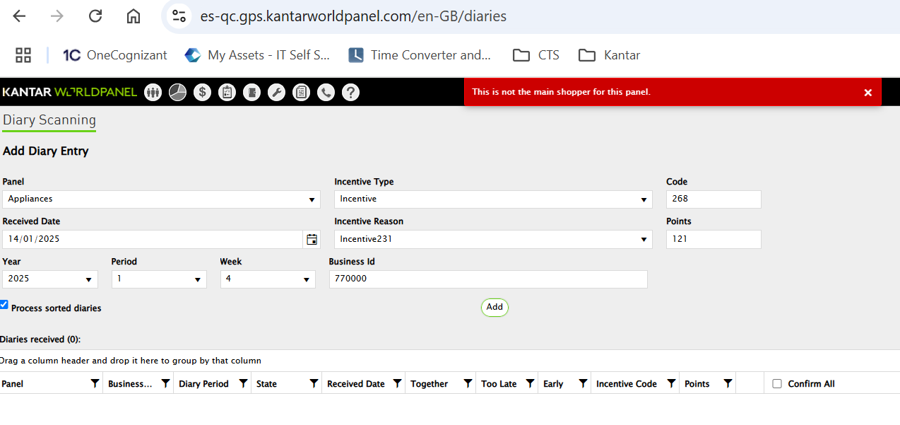

**Duplicate Diary:** – For single period for single businesses id for same panel can’t add duplicate diary.

**Together Flag**: – (Single Business Id for Single receive date for same panel three or more diary) In a single day if a panelist has submitted three or more diary for the same panel the together flag should set yes for all three diary, if panel manager deleted one diary from together diary that together flag should be removed for other two diaries as we have only two diary with one business id in a single day

**Too Late**: - Too Late flag need to set yes as if received diary is 6 weeks late including the previous week. It will not add the points to diaries received if they have the too late flag set to yes

**Early:** Early flag need to set yes if we received an early diary (When receive date is before then the Period Date range)

## Diary Management

Select the required Panel

Diary Management page will display 6 months record from the current period for the select panel. Default target period will be one period previous from the current period like diary scanning page.

Based on this, the calendars are displayed in the diary management screen. These types are based on the calendar and the specified date. We categorize them as either 'late' or 'early.' Once the data is added, it will be populated here.

If the customer is unable to send bills or upload them, we have reminders and communication methods from the business side. We can send an email to the Palace Vertical. I can send an email.

You can send an SMS or a WhatsApp message to them because you have all the information in GPM. You have their mobile number and home phone number. You can call them or send a message.

Since we have all these communication types in our GPM, like sending emails and SMS, we can communicate with the panellist. Moving ahead, we have daily management.



You will get the report here, including the business ID, periods, and diary types. All the loaded data will be displayed on the management screen.



By selecting the ERP, if we get a message for this panel for this period showing the number of claims as 0, it means no one has sent the data for this beauty panel in this period for this diary type.

Based on the calendar year, it can be a four-week or five-week calendar date. The data is sent to the user. The second period can be considered early, and if there is a delay.

For example, if Friday is the last deadline and there is a delay into the next week, it may be considered a late diary based on that data.

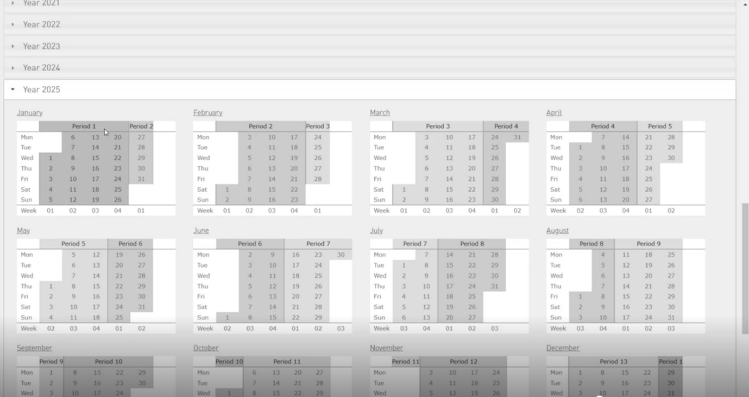

They can specify that if diaries are missing for the last three weeks and the diary is not scanned, an SMS, WhatsApp message, or email should be triggered. Using these templates, you can do it from the business rule.

Using this information, you can also change your panellist status. If they haven't provided any data for the past six weeks, you can drop them. We have a logic for this.

For some regions in Asia, based on your diary data, we have a logic that automatically drops the panellist if they don't provide data for a specified period. This is a configuration that can be handled by the business rule.

When you run it for the baby panel, your six months of data gets displayed here. All the scans for the past six months are displayed here, irrespective of the panellist. It shows all the data for this panel.

The claim flag is calculated based on the diaries submitted. I'll explain the logic of how it is calculated for the A/C.

 I submitted the diary. It will always be here, like the current week -1 and your diary type. Whether it's an online diary or self-scanning, because now the Asia market has become a self-scanning market. Earlier, it was not.

Now, they have become a self-scanning market. Then it's posted for paper. You must set the collaboration here for the claim to work. The collaboration methodology, whether it's a paper diary, non-diary, or self-scanning, must be selected here.

Earlier, it was not mandatory, but now it is. Whenever you add a panel, collaboration is mandatory. We will set some collaboration methodology. You must select the right collaboration methodology here.

If you want to check how the claim is calculated, you must select the collaboration methodology first. You must do a daily scan, then come to diary management to know how the missing claim works.

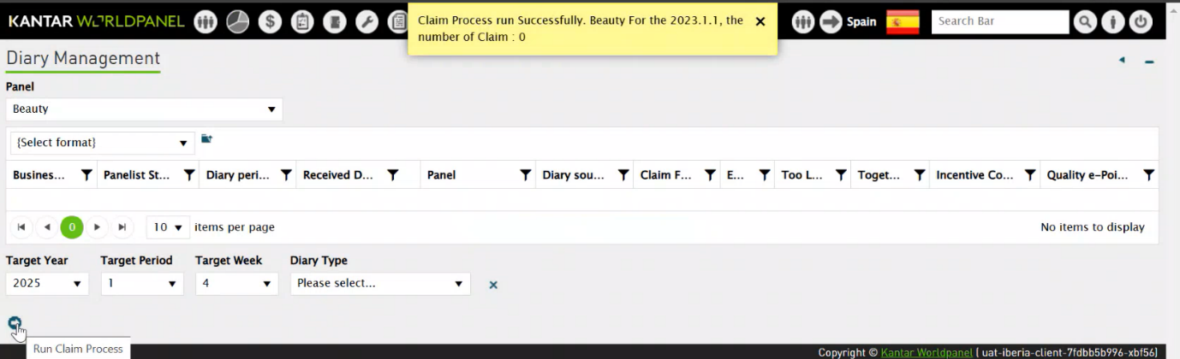

Suppose today is 2025.1.3. I submitted my diary, and it was scanned. When I run a claim for the current period, if the diary is scanned, it will not calculate a claim, regardless of whether you submitted a diary earlier or not.

If it is scanned, that's it for that period. If I did not submit the diary for 2025.1.2, remember that the calendar in GPM is always in reverse.

If the diaries are not scanned, and you are running it for 2025.1.3, there will be no claim.

You will see how many claims are flat, either 1, 2, 3, 4, or 5, or it will be 0. Suppose I run it on 2025.1.2 and 2024.1.4.

When I run the claim for this period, if there is no diary scan, it will calculate the claim until the period you have scanned. If I did not submit diaries for 2025.1.2 and 2025.1.1 but submitted for 2024.1.4, it stops there.

So, my claim will be two. If I did not do any diary scanning at all, it will go until your signup date. Until that period, it will calculate your claim flag and display it here.

For each period, it will record it in the diary management. It gets recorded in the database because we need to know whether the panellist has a claim or not.

If they don't have a claim, it will be 0. If they have a claim, it will be calculated according to the logic.

It depends on the diary type, so you only have your diary source here.  Your claim will not be calculated for dropouts, refusals, or uninterested panellists.

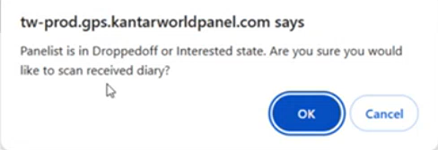

It is only calculated for pre-live panellists. There are three states we are calculating, which is part of the configuration. The diary is mainly used by Asia and not by any other country as of now.

Going forward, we are planning to replace the diary with Lumi, which is an SSIS that sits in the queue. The panellist will be informed. We are going to implement this in the future, so the current system might not be in place. But for now, we are still using it. Just wanted to give an update on that.

One of the diary histories includes your last month's scans, which are displayed there.

On the panellist screen, we can find the data in the diary history.

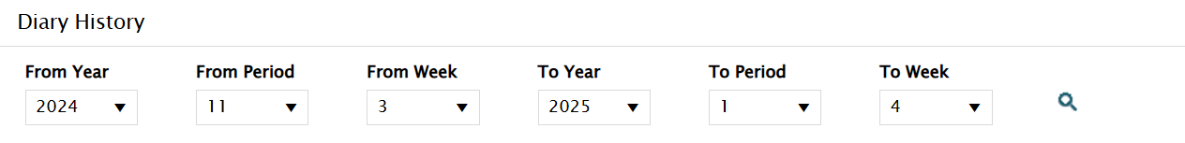

Here, we'll get all the data history for this individual or panel, including when it was sent out.

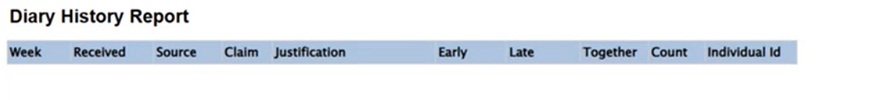This report is generated from SSRS. Your claims also appear here when you run your claim. Even if there are no scans, the report will still be displayed. You can view and modify the data here.

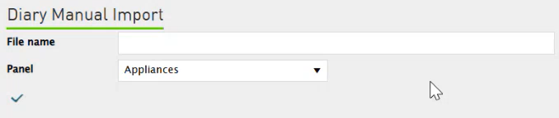

 This is the diary manual import. It includes only the files that we have already sent out to the panellists. They fill in all the data related to their purchases and then, at the end of a specified time, send back those diaries to Kantar, who then uploads the files.